**High level Search functionality Scenarios: -**

1. **Verify search box is present on page and search button is present/enabled.**
2. **Verify the Search results are displayed should be relevant to input search keyword**
3. **How many search results are displayed per page? Is pagination enabled when you have more results per page?**
4. **Verify the search results are not displayed while Search button clicked without entering any keyword**
5. **Verify the history maintained for the previously searched keywords**
6. **Verify when you search with a keyword that does not produce any result**
7. **(page should show proper message with a box to search again.)**
8. **Verify the Error Handling scenarios –**
9. **Verify UI - Test the search result with long text, error spellings, multiple spaces, and capital letters at the beginning, in the middle, and at the end of the word combination.**
10. **Special characters #/%/& should not redirect to error message**
11. **When user start typing word in text box it should suggest words that matches typed keyword**
12. **There should be pre-defined search criteria for auto complete e.g. after typing first 3 letter it should suggest matching keyword**
13. **When user clicks on any link from result and navigates back, then result should be maintained**
14. **After clicking Search field - search history should be displayed (latest search keyword)**
15. **All search keyword/filters should get cleared on clicking Reset button**
16. **Search results should be cleared on clicking clear search button**
17. **History displayed in search field should be relevant to logged in user only**
18. **Pagination should be tested for searches returning high number of records**
19. **Total number of search records/results should be displayed on page**
20. **Search keyword should get highlighted with color in the search results**
21. **search keyword should suggest similar kind of product/items**
22. **For Advanced Search - limited search filters should be provided**
23. **Water text should be provided for user to understand what to search**
24. **Validate search rules defined for “Exact Match” with the search key word**
25. **Validate search rules defined for “Similar Match” with the search key word**
26. **Validate search rules defined to search with a set of keywords**
27. **User should be able to search when he enters the keyword and hits ‘Enter’ button on keyboard**

**Test Automation Execution:**

1. **Run Test using Feature file**

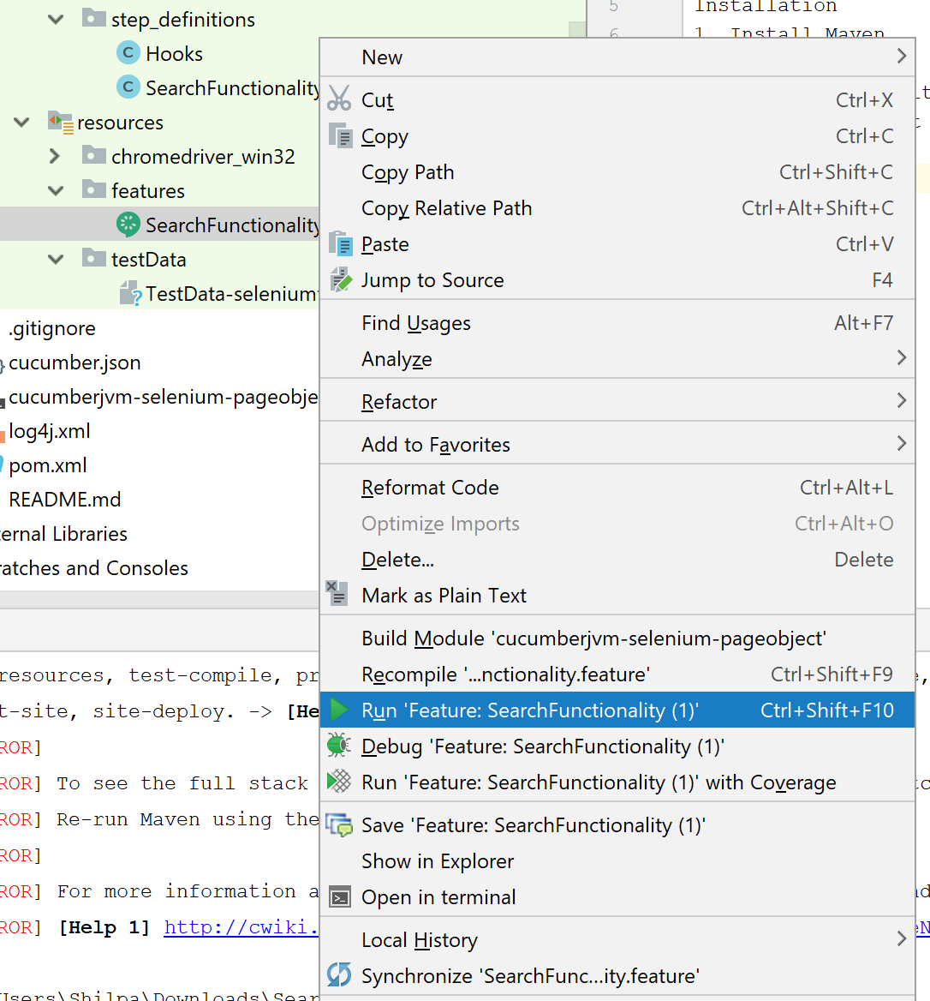

Result:-

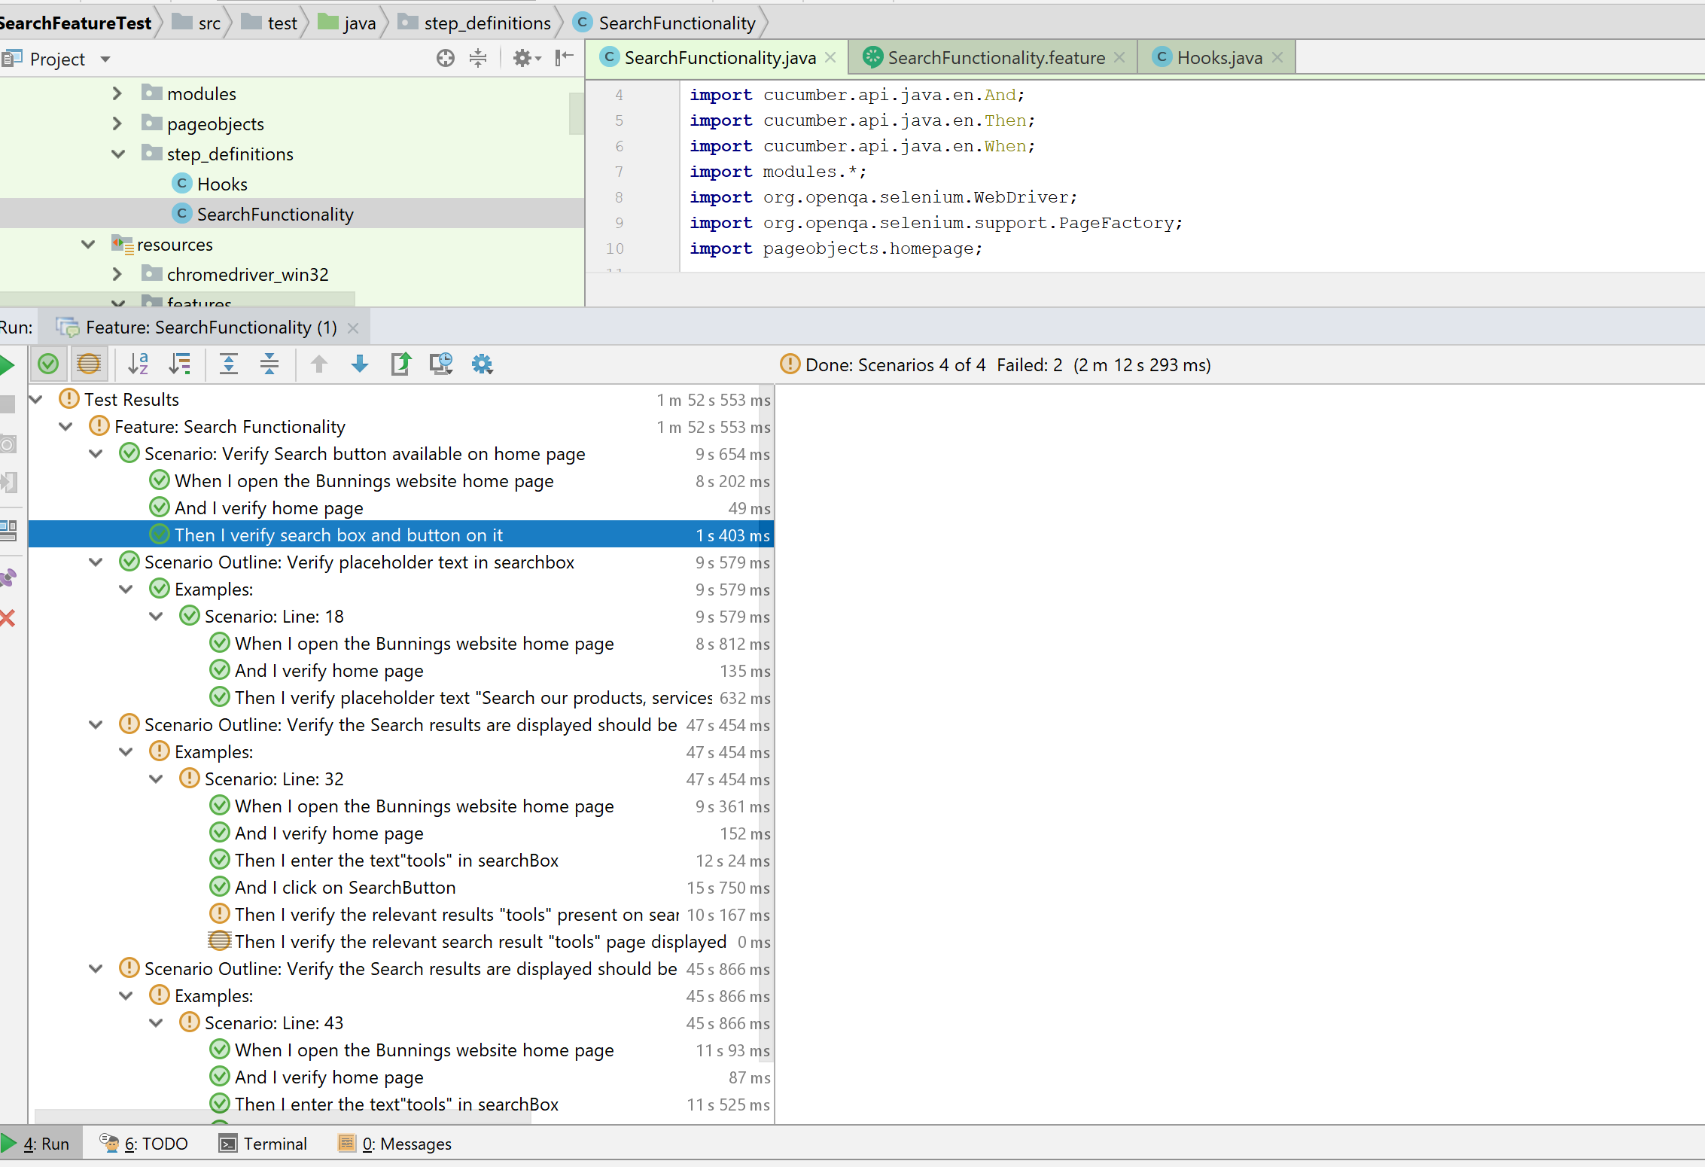

1. **Run Test using Test Runner Class.**

**Right Runner class and select run**

